MDS metrico y no metrico

[franmarq@gmail.com](mailto:franmarq@gmail.com)

2022-11-13

str(eurodist)

## 'dist' num [1:210] 3313 2963 3175 3339 2762 ...

## - attr(*, "Size")= num 21

## - attr(*, "Labels")= chr [1:21] "Athens" "Barcelona" "Brussels" "Calais" ...

summary(eurodist)

## Min. 1st Qu. Median Mean 3rd Qu. Max.

## 158 808 1312 1505 2064 4532

eurodist2=as.dist(eurodist) *#Lo ponemos en la clase dist.*

eurodist2

## Athens Barcelona Brussels Calais Cherbourg Cologne Copenhagen

## Barcelona 3313

## Brussels 2963 1318

## Calais 3175 1326 204

## Cherbourg 3339 1294 583 460

## Cologne 2762 1498 206 409 785

## Copenhagen 3276 2218 966 1136 1545 760

## Geneva 2610 803 677 747 853 1662 1418

## Gibraltar 4485 1172 2256 2224 2047 2436 3196

## Hamburg 2977 2018 597 714 1115 460 460

## Hook of Holland 3030 1490 172 330 731 269 269

## Lisbon 4532 1305 2084 2052 1827 2290 2971

## Lyons 2753 645 690 739 789 714 1458

## Madrid 3949 636 1558 1550 1347 1764 2498

## Marseilles 2865 521 1011 1059 1101 1035 1778

## Milan 2282 1014 925 1077 1209 911 1537

## Munich 2179 1365 747 977 1160 583 1104

## Paris 3000 1033 285 280 340 465 1176

## Rome 817 1460 1511 1662 1794 1497 2050

## Stockholm 3927 2868 1616 1786 2196 1403 650

## Vienna 1991 1802 1175 1381 1588 937 1455

## Geneva Gibraltar Hamburg Hook of Holland Lisbon Lyons Madrid

## Barcelona

## Brussels

## Calais

## Cherbourg

## Cologne

## Copenhagen

## Geneva

## Gibraltar 1975

## Hamburg 1118 2897

## Hook of Holland 895 2428 550

## Lisbon 1936 676 2671 2280

## Lyons 158 1817 1159 863 1178

## Madrid 1439 698 2198 1730 668 1281

## Marseilles 425 1693 1479 1183 1762 320 1157

## Milan 328 2185 1238 1098 2250 328 1724

## Munich 591 2565 805 851 2507 724 2010

## Paris 513 1971 877 457 1799 471 1273

## Rome 995 2631 1751 1683 2700 1048 2097

## Stockholm 2068 3886 949 1500 3231 2108 3188

## Vienna 1019 2974 1155 1205 2937 1157 2409

## Marseilles Milan Munich Paris Rome Stockholm

## Barcelona

## Brussels

## Calais

## Cherbourg

## Cologne

## Copenhagen

## Geneva

## Gibraltar

## Hamburg

## Hook of Holland

## Lisbon

## Lyons

## Madrid

## Marseilles

## Milan 618

## Munich 1109 331

## Paris 792 856 821

## Rome 1011 586 946 1476

## Stockholm 2428 2187 1754 1827 2707

## Vienna 1363 898 428 1249 1209 2105

**library**("smacof")

cmdscale(eurodist2, k = 20, eig = TRUE, add = FALSE, x.ret = FALSE)$eig

## [1] 1.953838e+07 1.185656e+07 1.528844e+06 1.118742e+06 7.893472e+05

## [6] 5.816552e+05 2.623192e+05 1.925976e+05 1.450845e+05 1.079673e+05

## [11] 5.139484e+04 -3.259629e-09 -9.496124e+03 -5.305820e+04 -1.322166e+05

## [16] -2.573360e+05 -3.326719e+05 -5.162523e+05 -9.191491e+05 -1.006504e+06

## [21] -2.251844e+06

*#Hacemos MDS métrico.*

resm.eurodist2 <- smacofSym(eurodist2,2,)

resm.eurodist2

##

## Call:

## smacofSym(delta = eurodist2, ndim = 2)

##

## Model: Symmetric SMACOF

## Number of objects: 21

## Stress-1 value: 0.072

## Number of iterations: 17

summary(resm.eurodist2)

##

## Configurations:

## D1 D2

## Athens 1.2139 1.0027

## Barcelona -0.4448 0.3499

## Brussels 0.0343 -0.2296

## Calais -0.0661 -0.2806

## Cherbourg -0.2703 -0.2687

## Cologne 0.1698 -0.2713

## Copenhagen 0.3858 -0.6136

## Geneva -0.0128 0.1806

## Gibraltar -1.1240 0.3928

## Hamburg 0.3276 -0.4260

## Hook of Holland 0.0934 -0.3450

## Lisbon -1.1087 0.0448

## Lyons -0.1034 0.1192

## Madrid -0.7976 0.1827

## Marseilles -0.1683 0.2898

## Milan 0.1541 0.2566

## Munich 0.3295 0.0534

## Paris -0.0949 -0.1354

## Rome 0.3846 0.5830

## Stockholm 0.5136 -0.9996

## Vienna 0.5843 0.1144

##

##

## Stress per point (in %):

## Athens Barcelona Brussels Calais Cherbourg

## 13.59 1.57 0.45 1.58 5.31

## Cologne Copenhagen Geneva Gibraltar Hamburg

## 11.15 5.50 11.22 2.14 1.32

## Hook of Holland Lisbon Lyons Madrid Marseilles

## 3.86 7.60 6.87 1.60 1.75

## Milan Munich Paris Rome Stockholm

## 1.66 1.43 0.42 12.47 5.66

## Vienna

## 2.85

plot(resm.eurodist2, main="smacofSym(eurodist2,2)")

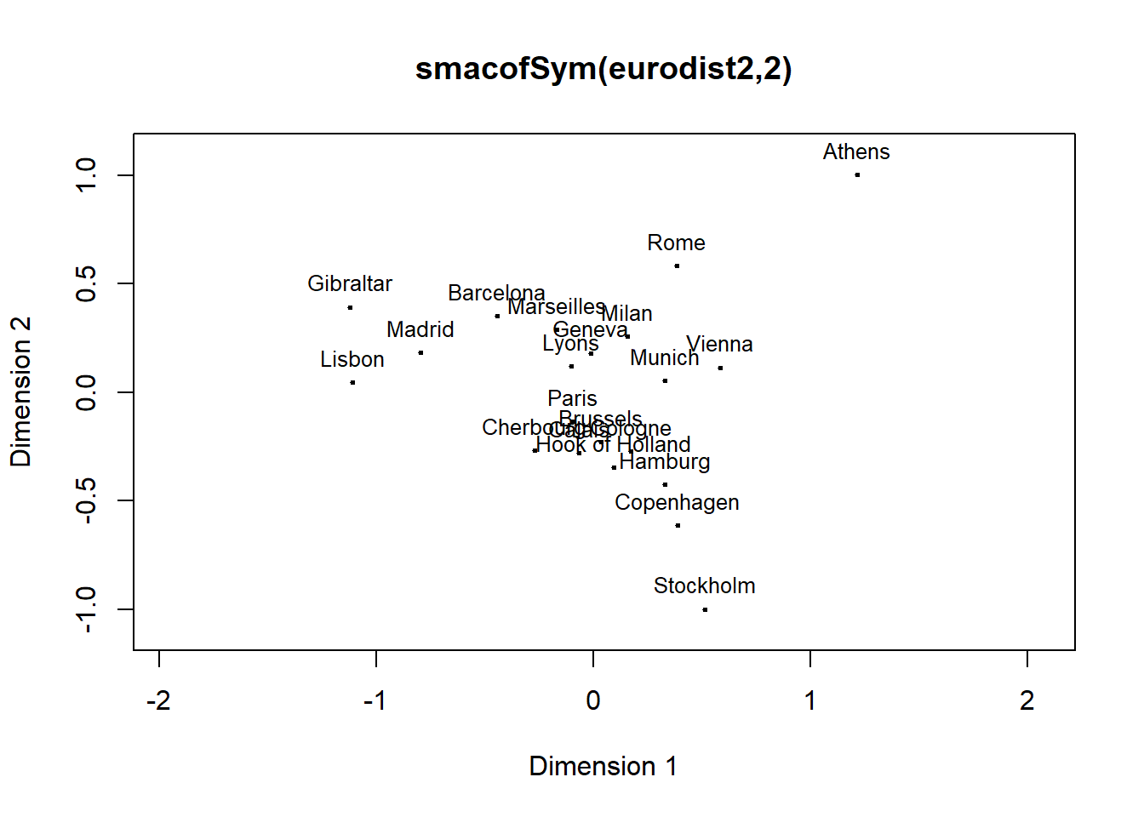

tabla1<-read.csv("tabla1.csv",header = T)

tabla1.diss=sim2diss(tabla1,1)

resnm.tabla1=mds(tabla1, ndim=2, type = "ordinal")

resnm.tabla1

##

## Call:

## mds(delta = tabla1, ndim = 2, type = "ordinal")

##

## Model: Symmetric SMACOF

## Number of objects: 10

## Stress-1 value: 0

## Number of iterations: 1

summary(resnm.tabla1)

##

## Configurations:

## D1 D2

## 1 0.0347 -0.2863

## 2 1.0085 -0.0695

## 3 -1.1181 -0.0847

## 4 -0.8135 0.0927

## 5 -0.0735 -0.0647

## 6 0.2286 -0.1353

## 7 0.4832 0.1508

## 8 0.3756 0.3190

## 9 -0.1395 0.6968

## 10 0.0139 -0.6189

##

##

## Stress per point (in %):

## 1 2 3 4 5 6 7 8 9 10

## 5.92 16.35 18.97 12.45 5.11 5.78 7.85 7.70 10.61 9.26

plot(resnm.tabla1,main='smacofSym(tabla1.diss,ndim=2,metric=FALSE)')

